Balmoral Legal Centre Squash Tournament
Hello, I just participated in the Balmoral Legal Centre Squash Tournament, and now I’m here to tell you about it. My name is Nicholas Titan, I placed second in the Junior A tournament. Over the weekend, I played three matches with some of my peers and with another junior player from Fort Frances. The tournament that I played in was only three games, but other divisions of the tournament would be much larger, with more competition. While playing, I enjoyed meeting new players from out of town, laughing with buddies, snack and drinks, and a party the night before the last game.
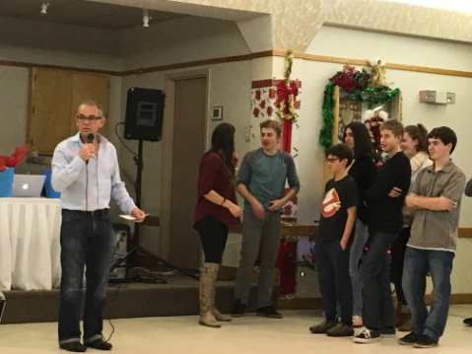
The competitors that I have played with in this tournament as well as others have always been very kind and sportsmanlike. You will find no one here that will treat you badly. No matter where you place yourself, there will always be a challenge, for example, my last game this year went to 2/2, and then I lost the final game by only a handful of points. The victor, my friend Jeremy, played very well, and we, along with another friend Steven, enjoyed some prizes!

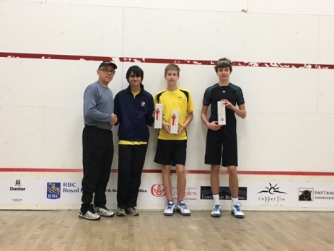
(Our coach Bob, Jeremy, Me, and Steven)
We have been training throughout the year for tournaments like this, and with people like Bob Shine, our coach, we have greatly improved over the years we have been part of the club. Everyone can come and play, improve, have a few laughs and learn about the game. We wouldn’t be where we are now without the many great people who push us to get better.
Overall, it was a very entertaining and fun weekend, and I would definitely recommend all who like the game to come and participate next year. Maybe I’ll see you there!

